Understanding the New CATCH Process for EU Fish Imports.
cormac658
Jan 21
4 min read
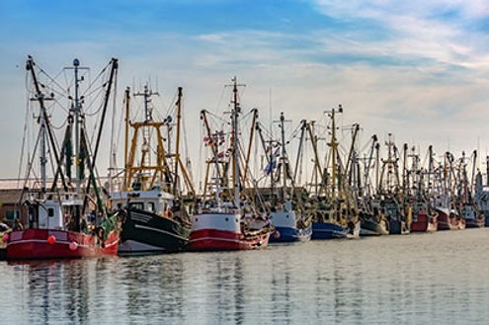
Fish and seafood imports into the EU have always been subject to a high level of control, but recent changes to the CATCH system represent a real shift in how those controls work in practice. For businesses importing fish into the EU has become a central part of how shipments are cleared and how delays are avoided.
At Customs Wise, we are already seeing the impact of these changes on live shipments coming through the system. The updated CATCH process is much more digital, much more interconnected with customs systems, and far less forgiving of mistakes than the old paper-based approach.

CATCH is the EU’s electronic system for managing catch certificates, which are required for all wild caught marine fish entering the EU from external countries. These certificates are designed to prove that fish have been caught legally and in line with international and EU rules on sustainable fishing. For years, this system existed in a fragmented way, with a mix of physical paperwork, national platforms and manual checks. The new version brings everything into a single EU-wide digital system, with authorities able to see, cross-check and validate information in real time.

In practical terms, the biggest change is that catch certificates now have to exist and be validated in CATCH before a customs declaration can be properly completed. Exporters or competent authorities in the country of catch create the certificate, but EU importers must make sure it is accurate, complete and properly endorsed. Customs authorities then check the CATCH reference as part of the import process, comparing it against the declaration, the invoice and the goods themselves. If something does not line up, the system flags it almost immediately.

This has shifted responsibility more clearly onto the importer. While suppliers and foreign authorities still play a role, the legal obligation ultimately sits with the business inside the EU bringing the goods into the market. Relying on a supplier to “sort the paperwork” is no longer enough. Importers now need visibility over what has been submitted in CATCH, if it has been validated, and whether it matches what is being declared to customs. Without that oversight, even small errors can lead to consignments being held or rejected at the border.

What is being seen in practice is that many of the problems are not dramatic compliance failures, but simple data issues. Species codes entered slightly differently, quantities that do not match exactly between documents, certificates that are created but not formally validated, or references that are missing from the customs entry. Under the old system, some of these might have slipped through. Under the new system, they are much more likely to be picked up automatically.

A major part of this is that the new CATCH system requires a significantly expanded data set compared to before. Information such as the fishing trip start date, gear type used, and much more detailed catch area data now has to be captured. This includes not just the FAO zone, but also whether the catch took place in an EEZ or on the high seas, and which RFMO applies. Transport data has also been extended, with details required on the first mode of transport from the export point, the point of entry into the EU, the final destination, and any additional transport legs if they are known in advance. All of this increases the level of scrutiny, but also the scope for errors if information is incomplete or inconsistent.

For importers, this means that timing and coordination are now critical. Catch certificates need to be in place well before goods arrive, not sent over at the last minute. There needs to be a clear understanding of who is responsible for creating the certificate, who validates it, and who checks it before the customs declaration is submitted. This is particularly important for chilled or frozen products, where delays at the border can quickly turn into commercial losses.

The wider context here is that the EU is moving towards much more data-driven enforcement across all areas of trade. Systems like CATCH are not just about sustainability policy, they are about building accountability and transparency into everyday customs processes. Once everything is digital, it becomes much easier for authorities to identify patterns and spot inconsistencies. From an importer’s point of view, this raises the stakes. Good compliance now means having clean, consistent data across multiple systems, not just having the right documents on file.

At Customs Wise, we are spending more time helping clients understand how CATCH fits into the broader customs picture, rather than treating it as a standalone requirement. That means reviewing supplier workflows and making sure customs declarations are aligned with what is in the new system. The aim is not just to avoid problems, but to make the process predictable and repeatable, so that fish imports can move through the border with minimal friction.

As the system continues to evolve, one thing is clear. CATCH is no longer a background administrative tool. It is now a core part of how wild caught marine fish imports are controlled in the EU, and it has real operational consequences for businesses. Importers who take the time to understand it properly will be in a much stronger position than those who leave it to chance.

If you have any questions regarding the new CATCH system, get in touch today to speak to a member of our dedicated food team.

